Deep Learning Based Automatic Detection Of Heart Disease Using Echocardiogram
¹, Mungamuri Rajeswari 2. Kottala Chaitanya Kumar
Department of Computer Science and Engineering Department of Computer Science Engineering
NRI Institute of Technology NRI Institute of Technology
Vijayawada, India Vijayawada, India
rajimungamuri3@gmail.com kottalachaithanyachaithu@gmail.com

3. Kale Likith Sai 4. Rajulapathi Poorna Sai Teja
Department of Computer Science and Engineering Department of Computer Science Engineering
NRI Institute of Technology NRI Institute of Technology
Vijayawada, India Vijayawada, India
likithsai217@gmail.com saitejarajulapati9@gmail.com
Guide Sir.Mr. M. V. P Uma Maheswara Rao
Assistant Professor
Department of Computer Science and Engineering
NRI Institute of Technology
ABSTRACT Heart disease is one of the major causes of death across the world, and early diagnosis is essential to reduce mortality and improve patient care. Echocardiography is a widely used non-invasive imaging technique that provides valuable information about the structure and functioning of the heart. However, analyzing echocardiogram images manually requires expert knowledge and is often time-consuming.Existing heart disease detection systems mainly depend on manual interpretation by cardiologists or traditional machine learning techniques that use handcrafted features. These approaches are prone to subjectivity, require extensive human effort, and often fail to achieve high accuracy and scalability when handling large medical datasets.To overcome these limitations, this project proposes a deep learning-based automated heart disease detection system using echocardiogram images. The proposed solution employs Convolutional Neural Networks (CNN) and Deep Neural Networks (DNN) to automatically extract meaningful features and classify heart disease conditions. The system is implemented as a web-based application supporting image upload, preprocessing, model training, real-time prediction, and performance visualization.Experimental results show that the proposed CNN–DNN based model achieves improved accuracy, robustness, and reliable prediction confidence when compared to conventional methods. The system effectively supports early diagnosis and can serve as a clinical decision support tool, with potential for future real-time and cloud-based deployment
KEY WORDS Deep learning, Echocardiography, Heart disease classification, Convolutional Neural Networks (CNNs).
I. INTRODUCTION  Despite improvements in healthcare, heart disease remains one of the leading causes of death worldwide, putting a huge strain on the healthcare systems of world. In 2019, the WHO estimated that about 32% of all deaths in the world around 17.9 million per year were due to cardiovascular diseases (CVDs) [1]. Together, these diseases, including CAD, angina, and hypotension that collectively bear significant economic and societal burdens [2]. Early diagnosis of cardiovascular disease can lead to effective treatment which may help stop morbidity and mortality rates.  Early detection is critical for heart disease. Early diagnosis and timely interventions can result in far better conclusion for patients. Clinical evaluation, electrocardiograms (EGCs), and good cardiac imaging are the prevalent diagnostic approaches, with echocardiography remaining a key player in structural heart disease diagnosis  [3]. The size of the heart, how well it works, valve | problems, and the enlargement of its chambers we can be studied using echocardiograms [4]. However, analyzing these images is a time sensitive and labor-intensive process that requires extensive training in medical imaging interpretation, necessitating the development of automated methods to aid clinicians in making faster and more accurate interpretations.  Ultrasound waves are used in echocardiography, a noninvasive imaging modality, to create images of the heart. It is essential for the identification and treatment of a number of cardiac disorders. According to [5] echocardiograms is used to assess heart function, find structural abnormality, and inform to therajpy choice. Echocardiography has benefits, but its reliance on professional interpretation has drawbacks, especially in places where access to qualified cardiologists is restricted [6]. As a result, there is now more interest in using cutting-edge technology, such deep learning, to facilitate the analysis of echocardiography pictures.

Artificial intelligence (AI) subfield deep learning has transformed several industries by allowing machines to learn and make judgments with little to no human input. Because they can automatically extract relevant features from unprocessed picture data, convolutional neural networks (CNNs), a kind of deep learning model, have demonstrated impressive success in image classification tasks [7] [8]. One well-known CNN design that has been quite successful in a variety of image identification applications, including medical imaging [9].
The classification of four different heart disease types— angina, coronary artery disease (CAD), hypotension, and cardiovascular disease (CVD)—is the main goal of this study. In previously mentioned situations on that based chose on their frequency and unique echocardiographic characteristics [10]. 2404 echocardiography pictures, evenly divided among the four illness categories, dream up the dataset used in this study. To increase the generalizability and performance.
Medical image analysis has significantly improved the result during recent developments in deep learning. Heart diagnoses could be revolutionized by combining deep learning and echocardiography, making it more dependable and accessible. Prior research has shown that CNNs may be used to perform a different range of medical imaging tasks, such as classifying skin lesions [11] [12] and identifying pneumonia from chest X-rays [13]. These achievements highlight the potential of deep learning to improve diagnostic efficiency and accuracy in a different medical field.
Our study findings show that the deep learning model can correctly categorize different heart conditions using echocardiography pictures. The excellent classification accuracy achieve highlights how deep learning models might improve echocardiography's diagnostic capabilities. Our model performance is thoroughly examined by the confusion matrix and classification report, which point out areas of strength and potential room for development.
This work concludes by showing that the deep learning model may be used to classify heart disorders from echocardiography pictures with both practicality and efficacy. This method has the potential to greatly increase the precision and effectiveness of cardiac disease diagnosis by automating the diagnostic procedure, which would eventually improve patient outcomes. By investigating the use of other deep learning architectures, incorporating multimodal data, and carrying out longitudinal studies to evaluate the effect of automated diagnostics on clinical practice, future research can improve on these findings.

II. LITERATURE REVIEW
Many researchers use ML classification techniques to predict heart disease. The ML classifiers used in this work have shown promising results in detecting the risk of CVD. The improved patient outcomes and the earlier identification of heart disease that medical imaging-based detection offers have made this field a focus for much research. Existing imaging techniques for finding cardiac abnormalities are limited; these include computed tomography (CT) scans, magnetic resonance imaging (MRI), and echocardiograms. Several studies have utilized ML algorithms like SVM, artificial neural networks (ANN), DT, LR, and RF to analyze medical data and predict heart diseasesNonetheless, these methods typically rely upon clinical expert understanding for-photo analysis as well intense undependability along with possibility in individual mistake.
Overall, cardiac dysfunction is a common consequence of cancer treatment. It is essential to detect the conditions at the earliest stages and prevent them. A recent study [14] investigates machine learning models for predicting cancer therapy-related cardiac dysfunction (CTRCD) in 4309 cancer patients. The model that is used achieved high accuracy in predicting outcomes like heart failure (AUROC: 0.882) and coronary artery disease (AUROC: 0.821). Clinically relevant variables such as age, hypertension, and glucose levels were found to be significant predictors. The findings suggest that machine learning can enhance cardiac risk stratification in cancer patients, supporting early detection and prevention of CTRCD The article da Silva et al. used machine learning to incorporate more than 4,300 patient records. By analyzing the predisposing factors and various variables, the team found out the most influencing factors such as age, hypertension, and glucose. These models can be used to predict and defend the patients from potential cardiac failure [14].
A survey explores deep learning's impact on medical imaging, addressing challenges like sparse labels, interpretability, and federated learning. It highlights advances in network architectures and applications in pathology, chest, brain, cardiovascular, and abdominal imaging, offering insights into emerging trends and future directionsDeep learning is a method to perform automatic feature extraction and learn such features directly from raw data, as its popularity grew up in the recent years one of its potential applications was on medical imaging. More specifically, convolutional neural networks (CNNs) were popularized for image recognition tasks. In 2021, using a CNN to recognize heart failure from MRI pictures required substantial progress in terms of accuracy over traditional way [15].
Advancements in AI are transforming valvular heart disease management by enhancing echocardiographic assessments, automating image analysis, and identifying high-risk groups. AI aids in view identification, valve segmentation, and disease detection, while integrating imaging with clinical data to predict disease progression and support precision medicine Scientists looked into the use of this photo evaluation in finding valvular, coronary heart illnesses via way of means of utilizing CNNs to photos that have been achieved in the from echocardiography. Through this study, provided information about how advanced deep learning models can identify specialized cardiac diseases very accurately demonstrating the potential that these tools could reduce clinicians' diagnostic load and increase diagnostic reproducibility [16]. Another study addresses heart murmur classification using CNN models like ResNet and VGGNet, applied to spectrogram and MFCC representations from the PASCAL CHSC dataset. ResNet outperformed VGGNet, with larger hop-length representations yielding higher accuracies. Future work includes exploring advanced models like InceptionV3 and Vision Transformer for improved prediction.This study is similar to the previous one, as it also involved detection of heart murmurs from phonocardiogram recordings using CNN. With an accuracy of 90%+, it demonstrates how DL can be applied to a diverse field of cardiac imaging modalities [17].
Deep learning, particularly convolutional neural networks (CNNs), revolutionized medical imaging analysis after the release of ImageNet in 2012. Another study reviews DNN applications in classification, detection, localization, and segmentation across various imaging modalities like X-Ray, MRI, and CT. While CNNs excel in image feature extraction, challenges such as training time, data augmentation, and annotation remain. Future research focuses on enhancing
DNN frameworks and advancing healthcare applicationsDeep learning application to medical image classification has grown exponentially. CNNs are often the default network to use for image data because they work so well with pictures. These networks contain multiple layers of learning which learns automatically from Photos input, like edges, textures, patterns.
The review [18] . A study by [19] utilized a large dataset proposes a dual-branch CNN for mammographic image classification, integrating mediolateral oblique and craniocaudal views with attention blocks and a fuzzy clusterbased penalty term to enhance feature extraction and generalization. The model outperformed state-of-the-art methods on INbreast and MIAS datasets. It emphasizes key features and complementary view information, improving accuracy. However, its effectiveness on larger, diverse datasets requires further validation. starts by acknowledging the advances in DL techniques - from classical machine learning approaches to modern neural network structures like Convolutional Neural Networks (CNN) and Recurrent Neural Network (RNN), or their iterations Image Classification, Segmentation & Detection are among the tasks in which these architectures have improved significantly and revolutionized Biomedical image analysis. State-of-the-art results mapping deep learning to mammograms for breast cancer identification have been achieved by using CNNs trained to region of interest extracting [19] Similarly, another study by [20] introduces BreastNet-SVM, a nine-layer CNN model combined with SVM for automated breast cancer detection from mammograms. Trained on the DDSM dataset, the model achieved 99.16% accuracy, 97.13% sensitivity, and 99.30% specificity, outperforming existing methods. It enhances diagnostic precision by leveraging deep learning and SVM for robust feature extraction and classification. The performance on more diverse and larger datasets remains untested[20].

III. PROPOSED METHOD
In this study, a theoretical explanation of the deep learning technique is necessary for understanding the methods. More research is being conducted in the present era of technology to use CNN [44] to solve a number of medical issues [45], including the identification of brain diseases, the categorization of heart diseases [46], breast cancer [47], and so forth.
A convolution neural network's input constantly favors a certain type of image, and it uses filters to identify temporal and spatial aspects in images in addition to detecting properties like color, texture, and edges [48]. CNN will use weight distribution algorithms with fewer parameters to cut down on computing time. There are filters and kernel sizes in each layer. The pooling layer helps distinguish the features separately by reducing the size of the feature map and generalizing characteristics that were extracted by earlier kernels following convolution. The most popular pooling layer, max-pooling, divides the inputs into squares of a given size; the output is the largest value of all the squares. Next, the average pooling layer computes the average of all squares, which helps to minimize computation and image size. When appropriate caution is taken, the work done with CNN model for diagnosing cardiac problems using a large dataset yields better results than a smaller dataset [49].
This proposed model relies on deep Convolutional Neural Network (CNN) [50] structure to capture and analyze complex features from input images. The network starts with an input layer that is intended to take in the 224x224-pixel image 3 color channels. A series of convolutional layers are then used to learn hierarchical feature representations. This model begins with two 64 filter convolutional layers, followed by two sets of double and triple the number of filters (128 /2 then 256/3), ending in a pair that contains again double (512) instead. The convolutional layers use a 3x3 kernel size and apply Rectified Linear Unit (ReLU) activation functions to add non-linearity. The purpose of this sequence is to allow the network learns increasingly abstract and complex features from pictures.
MaxPooling layers are added after each pair of convolutional layers in order to reduce spatial dimensions and emphasize the most salient features. These layers work by sub-sampling the feature maps reducing their size using a 2x2 window, allowing for computational savings and reinforcement of runtime invariance. Final Global MaxPooling Layer, It is now common to add a last layer which calculates the max value of each feature map such that global spatial information can be gathered from our most numerous and strongest features in 1D signal. This tensor is then sent through fully connected Dense Layers with Regularization techniques like Dropout to avoid Overfitting and Improve the generalization. Finally, the network ends with a Dense layer which has been activated by SoftMax and thus generated probability distribution among output classes for classification problem. Figure 1 provides a detailed examination of the modified VGG16 architecture, and the details of each layer are also explained after the diagram.

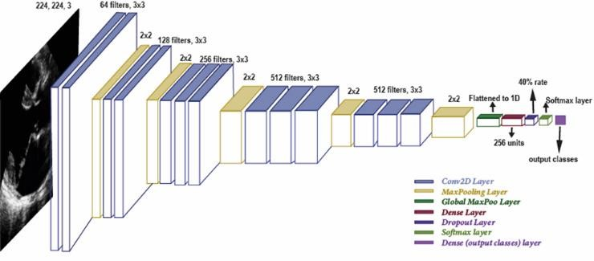
Overview of the modified VGG16 architecture.

A. INPUT LAYER
The input layer of the model requires that images have 224x224 pixel image resolution and a color channel size of 3 (i.e., RGB). This machine is used to receive and enter the raw data which then passes through a convolutional neural network also known as CNN in order for it to start processing

B. CONVOLUTION LAYERS
The convolutional layers are the basic building blocks of a CNN and they try to capture spatial hierarchies in image inputs. The model starts with two series of double Conv2D layers having 64 filters each, then two with 128 filters two and three sets with very large number filters is equal to hidden state, i.e., 256 followed by two for 512 filtered ending one set at the final time stamp. Conv2D layer is followed by a Rectified Linear Unit (ReLU) activation function for introducing the non-linearity in our network and trying to create output that can be complex patterns from input data.

C. MAXPOLLING LAYER
A MaxPooling layer with a window size of 2x2 follows after each pair of convolutional layers. This operation reduces the spatial dimensions of feature maps and removes irrelevant features from them. MaxPooling reduces over-fitting and compensates for some variance by focusing on informative features of data.

D. GLOBEL MAXPOLLING
Then this convolutional stack is followed by a Global MaxPooling layer towards the end. This will reduce the spatial dimensions from a feature map to a 1-dimensional vector containing the maximum value of each channel. With Global MaxPooling, the more moral features of a feature map are aggregated in one place and then used as input to further fully connected layers.

E. DENSE LAYER
After convolutional and pooling, a Dense layer of 256 units is used. The final, fully-connected layer combines these high-level features into a single predicted output value (per class) which can be used for classification. The Dense layer is activated using the ReLU function and embeds L2 (0.016) and L1 (0.006) regularization methods to counter overfitting, which helps in generalization on unseen data.

F. DROUPOUT
Moreover, a Dropout layer with rate of 40% is added after the Dense layer which will be used to further prevent overfitting. A proportion of neurons are randomly deactivated during training via Dropout to force the network to learn redundant representations, making it more robust and generalizable.

G. EQUATIONS
The final layer of the model is a Dense layer with units corresponding to the number of output classes, activated by the SoftMax function. SoftMax normalizes the output into a probability distribution over the classes, facilitating categorical predictions. This layer outputs the model's prediction probabilities for each class, making it suitable for multi-class classification tasks.

This architecture is structured to progressively extract and transform image features through convolutional and pooling operations, culminating in a compact representation suitable for classification via fully connected layers and SoftMax activation.
This work is aimed at enhancing the performance of deep learning in heart diseases classification for a better clinical decision. The importance of this study is its potential to bridge the gap between state-of-the-art AI technologies and clinical practice in cardiovascular medicine. An increasing amount of echocardiography data is being generated, redrawing the lines in favor of automated technologies that can assist with early and accurate detection heart disorders.

Histogram showing the number of images in each class.

We also visualized sample images from each class to get an intuitive understanding of the data. These images illustrate the variations within each class and highlight the types of echocardiogram images used for training and testing the model

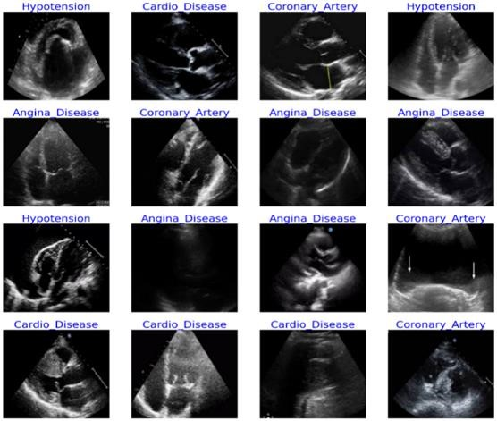

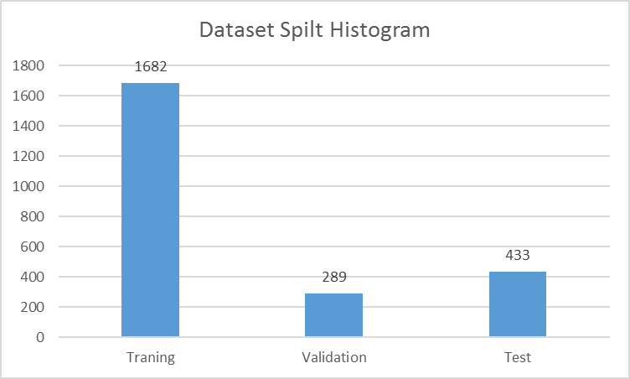
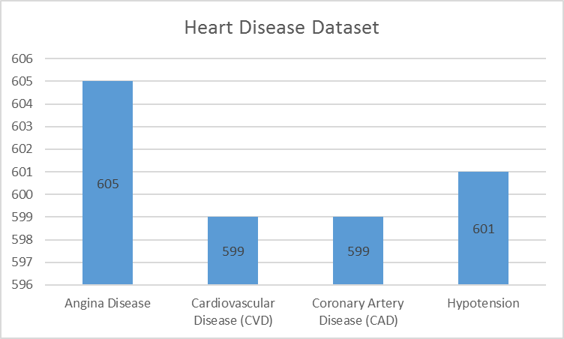
IV.

EXPERMENTAL RESULTS

Our research dataset includes a total of 2404 echocardiogram
Angina
images
and
class
labels
namely
Disease,
Cardiovascular Disease (CVD), coronary artery disease
(
CAD) & Hypotension. We used a reliable dataset from
Kaggle which was annotated by Marian Card
iac Centre heart
specialist, Poland. We created histograms to see how our
dataset
is distributed. The histograms illustrate the
distribution of images over each class. This is a visualization
to check our dataset it should be balance and representable

from each class like in Figure
2
.

Sample images from each class
.

Then we split the data into three subsets: training, validation,
and test sets, with a ratio of 70%, 12%, an
d 18%
respectively.

See the figure 4.

Data Split for Training, Validation, and Test Sets
.

Absolutely, this paragraph depicts how exactly the classification of cardiovascular diseases looks like if we try to do it from ECG images. This experiment was run with Kaggle’s P100 GPU in Python. Python was used to train and deploy the model, with 100 epochs of training. P100 GPUs enabled fast processing & training, leading to better model performance and accuracy. To examine how well our algorithm generalizes for this task, we ran different experiments with differing configurations. Here, we show the results and analysis of only three experiment which has best accuracy. The use of VGG16 in different configurations conducted experiments provided helpful insights into the classification of heart disease from echocardiogram images.

A. FIRST EXPERIMENT (VGG-16)
For the first experiment (VGG-16)[51], we will make use of
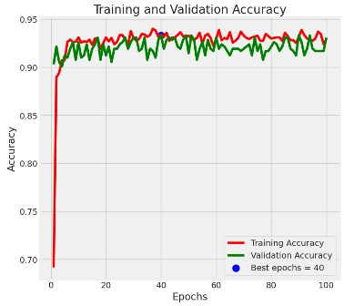
base VGG16 model and we obtained an accuracy as 92.18% which means that pre-trained VGG16 is much powerful for this task without any other modification. But using more layers and regularization techniques in the following experiments all had different levels of success. The training and validation accuracy over epochs were plotted. These plots help us to understand how the model did compare it’s in previous epochs They allow us to see how quickly the model is learning and how well it generalizes to data that's outside of what was visible.Training and Validation Accuracy (VGG-16).

During the experiments we have generated the confusion matrices of validation set. The confusion matrix gives you a detailed breakdown of the model's performance, and shows how many of each class label were correct vs. incorrect predictions. This analysis helps us to find out some classes wherein the model might not be well and it gives an overview of where we can do better. Confusion Matrix (VGG-16).

B. SECOND EXPERIMENT (EfficientNetB3)
In second experiment EfficientNetB3 model is used due to its computationally demanding nature. In this case EfficientNetB3 leverages the small compact model with more or less accuracy balance and is a good candidate for our task. I instantiated the EfficientNetB3 model with weights pre-trained on the ImageNet dataset. We predict using EfficientNetB3 with the default settings to do this. EfficientNetB3 model 94.53% efficient This is better than the 92.18% achieved by VGG-16 baseline model. Training and Validation accuracy over epochs for EfficientNetB3. Like the previous experiments, these plots can give some ideas of how well this model learns, and how it behaves in
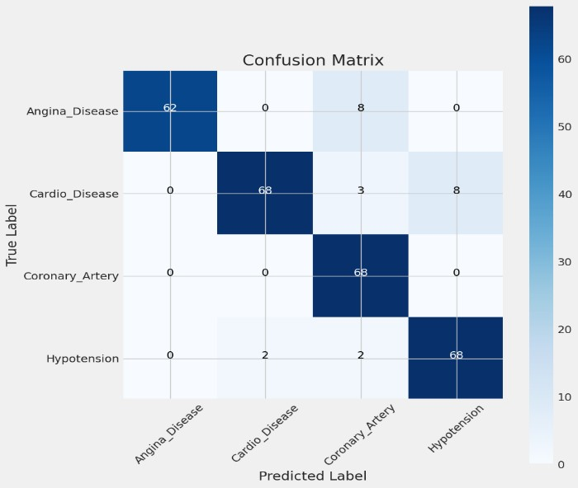
generalization. The training and validation accuracy over epochs were plotted figure 7.
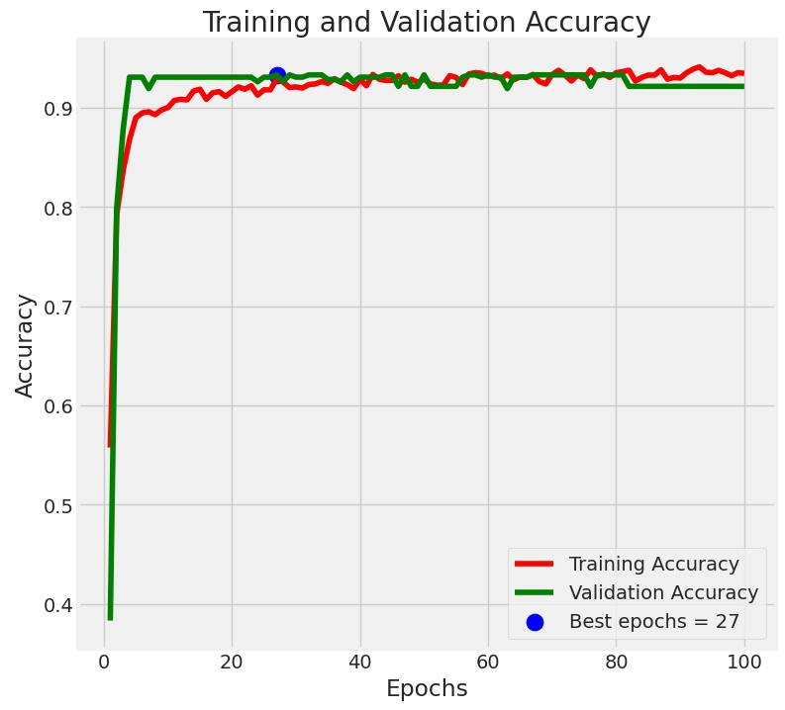
Training and Validation Accuracy (EfficientNetB3).
This confusion matrix was made for the EfficientNetB3 model, which shows how well our validation data performs for each of the classes. The matrix is showing how many predictions fall into particular classes and what areas of the model are good at, and which needs to be improved.
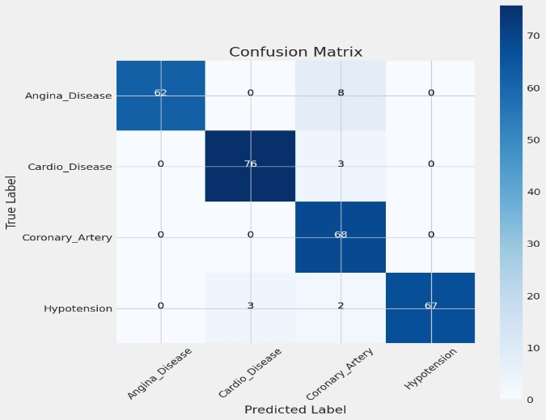
Confusion Matrix (EfficientNetB3).

C. THIRD EXPERIMENT (PROPOSED METHOD)
Experiment three (Proposed Method) Batch Normalization, Dense layers and Dropout rate of 0.4 with momentum of 0.99 got the highest accuracy which is 94.92%. This exceeded performance of the original base model and shows you how seemingly small hyperparameter tuning differences affect final accuracy. Similar to 1st & 2nd experiment the training and validation accuracy over epochs were plotted.
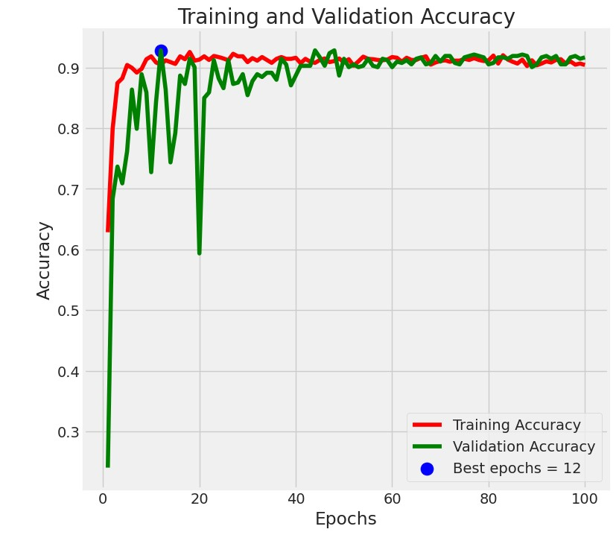
Training and Validation Accuracy (Proposed Method).
Similar to 1st & 2nd experiment during the experiments we have generated the confusion matrices of validation set. The confusion matrix gives you a detailed breakdown of the model's performance, and shows how many of each class label were correct vs. incorrect predictions. This analysis helps us to find out some classes wherein the model might not be well and it gives an overview of where we can do better.

Confusion Matrix (Proposed Method).
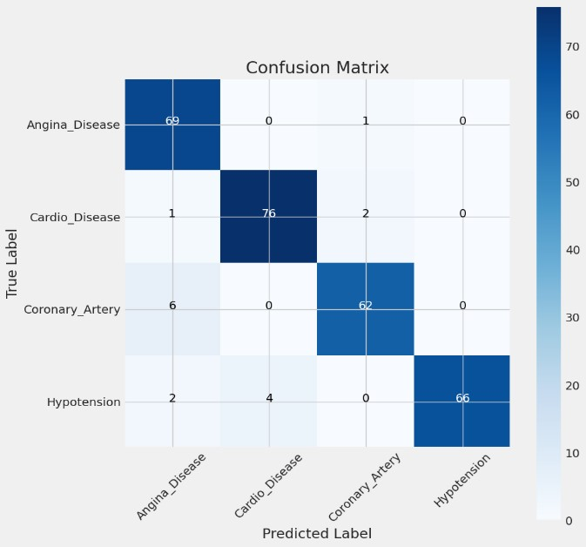

V. RESULTS DISCUSSION
The performances in terms of the accuracy, precision, recall and F1-score was measured to evaluate our model. These metrics have the equations given in Equations 1 to 4. Precision Formally, the proportion of true positive in all predicted as positives. Precision This calculates how many of the correct changes are actually proper, meaning not coming from a normal ECG sign. Recall measures, of all the actual positive cases that exist, what proportion is captured. The F1score score is the harmonic mean between precision and recall. where TP, TN, FP, and FN indicate True Positive, True Negative, False Positive, and False Negative.

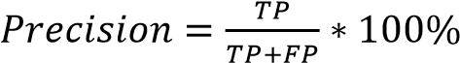………………………... (1)
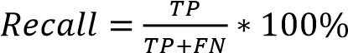 ………………………..... (2)
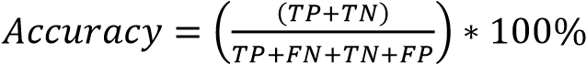…………….... (4)

Although VGG-16, EfficientNetB3 & Proposed Method are all classification models, their performance on the task of classifying heart disease from ECG images is compared. In F1-Score, VGG-16 achieved 92%, EfficientNetB3 achieved 94.25%, and the proposed method obtained the highest at 94.50%. In test accuracy, VGG-16 scored 92.18%, EfficientNetB3 scored 94.53%, and our proposed method achieved the highest accuracy at 94.53%. This proves how well our proposed method works, even with new data. To understand this, illustrate the diagram that show below Figure 11.

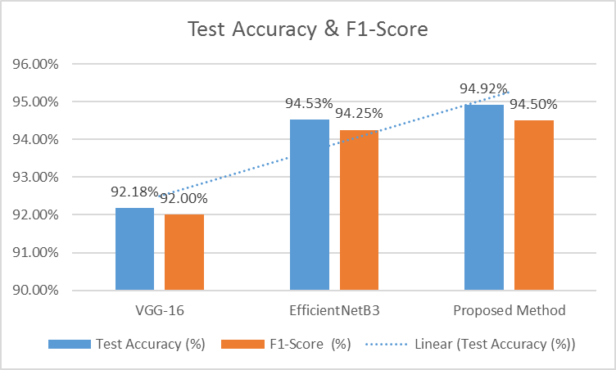
Comparing different model (VGG-16, EfficientNetB3 & Proposed Method).
In terms of the disease categories, Table 1 below compares performance of VGG-16, EfficientNetB3 and our proposed method on four medical conditions i.e., Angina Disease, CVD (cardiovascular disease), CAD (coronary artery disease) and Hypotension in terms of Precision Recall F1Score. Our proposed method also showed good scores in Angina Disease (88% for our approach, however there are two models achieving 100% which were VGG-16 and EfficientNetB3). Although it has an accuracy of 95% that makes a bit slightly bad in comparison to VGG-16 (97%) and EfficientNetB3 at almost exactly the same values. In CAD, our method shows by far the best results with a precision of 95%, in comparison to VGG-16 and EfficientNetB3 at only 84%. For hypotension, it has the most perfect accuracy as EfficientNetB3 (100%); then VGG-16(89%).
The proposed method performed best when examined from the point of recall, marking highest average-recall for Angina Disease (at 99% ), followed by VGG-16(89%) and EfficientNetB3(both at 88%). This is also matching the best recall for CVD (96%, higher than VGG-16 86%). For the CAD although perfect recall (100%) is achieved with VGG-16 and EfficientNetB3, our method still performed well at 91% For Hypotension, the Recall of our method is 92%; thus, less than VGG-16 (94%) but better compared to EfficientNetB3 model which is about around at 93%.
The proposed method performs exceptionally well in F1Score. It gets a score of 93% in Angina Disease, which is slightly worse than VGG-16 (94%) and the same as EfficientNetB3. For CVD, 96%, matching EfficientNetB3 and better than VGG-16 (91%) The most striking comparison is when applying the metric F1-Score to CAD, our method obtains a much larger score than VGG-16 (93% vs 91%) and even EfficientNetB3 in cloud infrastructure. Highest F1-Score(Detection) Hypotension, Highest= 96%, better than VGG-16(92%).
In all, our proposed method performs better on many fronts. The model is very effective on all classes, in a way that it has the biggest F1-Scores for CAD and Hypotension while reaches also at highest recall values for Angina Disease and CVD, with perfect precision rate of 100% only reserved to Hypotension. The results demonstrate the effectiveness of our proposed method in medical condition classification and also its strength on robustness.

TABLE 1
Comparing (VGG-16, EfficientNetB3 & Proposed Method) classification report includes precision, recall & F1-score.
Experiment | Metrix | Angina Disease | CVD | CAD | Hypotension
VGG-16 | Precision | 100% | 97% | 84% | 89%
 | Recall | 89% | 86% | 100% | 94%
 | F1-Score | 94% | 91% | 91% | 92%
EfficientNetB3 | Precision | 100% | 96% | 84% | 100%
 | Recall | 89% | 96% | 100% | 93%
 | F1-Score | 94% | 96% | 91% | 96%
Proposed Method | Precision | 88% | 95% | 95% | 100%
 | Recall | 99% | 96% | 91% | 92%
 | F1-Score | 93% | 96% | 93% | 96%

The number of instances for each class (support values) is constant throughout the all models that are comparing which means our data have an equal distribution. For better understanding we illustrate the chart see the Figure 10.

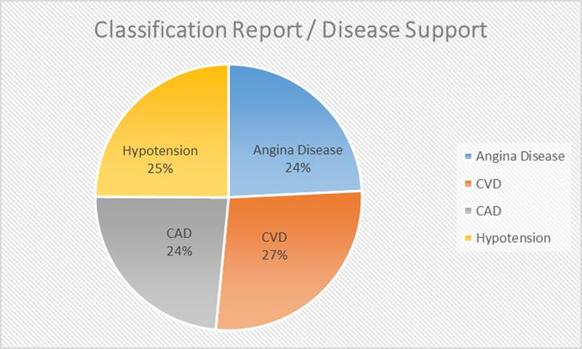

Classification Report / Disease Support.
The results from the experiment demonstrate that the proposed method outperforms both VGG-16 and EfficientNetB3 in classifying heart diseases from ECG images. In terms of F1-Score, the proposed method achieves a highest value of 94.50%, surpassing VGG-16 (92%) and EfficientNetB3 (94.25%). It also excels in test accuracy (94.92%) and achieves the best recall values, particularly for Angina (99%) and CVD (96%), showing its ability to correctly identify positive cases without missing critical instances. While VGG-16 shows strong precision, particularly for Hypotension, its lower recall for Angina and
CVD suggests it may miss some positive cases. EfficientNetB3, on the other hand, performs better than VGG-16 in recall, particularly for CVD (96%) and CAD
(100%), but it still falls short of the proposed method’s overall balanced performance. The proposed method consistently delivers high precision, recall, and F1-Score across all disease categories, indicating it has the best generalization ability, which is crucial for real-world medical applications where both false positives and false negatives can have significant consequences. This makes the proposed method the most reliable model for heart disease classification from ECG images, offering a promising tool for early diagnosis and better clinical decision-making.
In this total summary, we use a dataset of 2404 echocardiogram images (Angina Disease, Cardiovascular Disease (CVD), coronary artery disease (CAD) and Hypotension). We used a well-known dataset from Kaggle and experimented with VGG-16, EfficientNetB3 for evaluating our method. Experimental results demonstrate the superiority of our proposed method over several conditions in terms precision, F1-Score and recall. It also exhibits the best performance in terms of F1-Scores for CAD and Hypotension, recall for Angina Disease and CVD as well perfect precision on classifying samples that are negatives to test results. Our proposed method achieved the highest accuracy of 94.92%, compared to VGG-16 at 92.18% and EfficientNetB3 at 94.53%. This result provides support for the efficiency and reliability of our proposed solution towards medical status categorization.
Currently, we are only working with echocardiogram images. In the future, we plan to work on videos. If the concern is about the future scope, the model will be implemented after real-time testing for disease classification.

VI. CONCLUSION
In our research we've studied the potentials of deep learning using VGG16 based models Its variants for classification heart disease from Echo-images. Unmodified VGG16 obtained an impressive accuracy of 92.18%, indicating that it can efficiently and effectively identify heart diseases from echocardiograms images. In the other experiments we introduced additional layers and regularization techniques, but they allowed to obtain a lower accuracy. These results emphasize the importance of hyperparameter tuning on the other experiment, which use a dropout rate of 0.4 and momentum of 0.99 resulted an accuracy above all models performing with up to now (94.92 %). This implies that with the right amount of regularization, you can get your model to improve its performance and not overfit. Contribution to medical imaging and heart disease detection, our research contribution within the domain of Medical Imaging and Heart Disease Detection has few important things. It supports the efficacy of deep learning models, especially VGG16 in classifying various heart diseases correctly from echocardiogram images. In this work we give our perspective on how those hyperparameters dropout rate and momentum played the most relevant role in model performance. These results should guide future studies which aim to enhance deep learning models for medical image classification. This study further explores to parse optimal hyper parameters for regularization, fine tuning the VGG16 architecture which leads us to a better model configuration of heart disease classification. Although this study yields seminal results, many future directions would benefit the field greatly. First, given the vast landscape of deep learning architectures, further architectures should be investigated. ResNet or Inception are architectures that might perform better than the VGG model used in this study, or perhaps they can converge more rapidly. Secondly, a larger and more varied dataset should be available. This way, the model can generalize well to any patient and be more robust. Furthermore, specific data augmentation methods still can be used to artificially extend the data and diversify them. Finally, more sophisticated hyperparameter tuning techniques should be developed. For example, grid search or Bayesian optimization can be used to more rigorously search for best possible configurations. Another solution is to explore more possibilities for using Transfer Learning from other medical imaging tasks and fine-tuning pre-trained models on echocardiograms images. In this case, it is possible to achieve higher accuracy. Last but not least is the clinical validation of the developed models on actual data, to be sure that they can be more practically useful and reliable in real-world clinical applications.

